**Project Design Phase-II**

**Flow Diagram & User Stories**

|  |  |
| --- | --- |
| Team ID | PNT2022TMID15047 |
| Project Name | SMART WASTE MANAGEMENT SYSTEM FOR METRO  POLITIAN CITIES |
| Maximum Marks | 4 Marks |

RECOVERY

OF METALS

RECOVERY

OF METALS

LARGE HOUSEHOLD

APPLIANCES

TRANSPORT TO

RECYCLING

PLANT

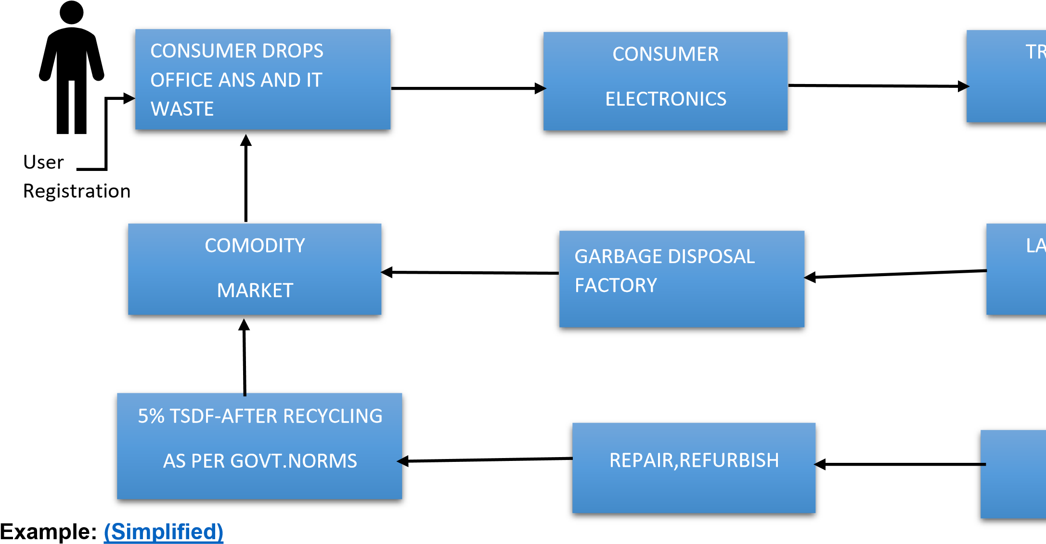**Data Flow Diagram**

**User Stories**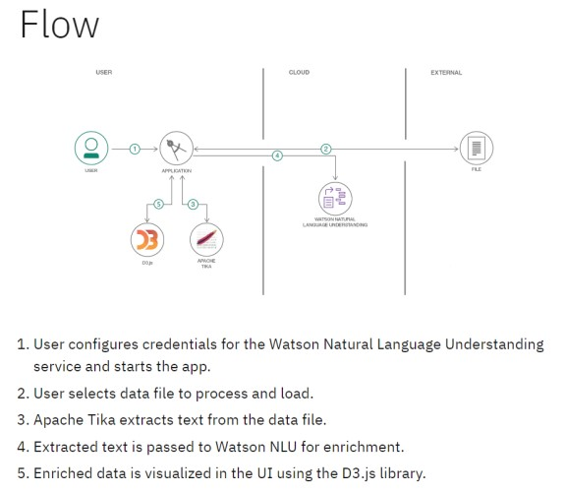

Use the below template to list all the user stories for the product.

|  |  |  |  |  |  |  |
| --- | --- | --- | --- | --- | --- | --- |
| **User Type** | **Functional**  **Requirement (Epic)** | **User**  **Story**  **Number** | **User Story / Task** | **Acceptance criteria** | **Priority** | **Release** |
| Customer  (Mobile user) | Registration | USN-1 | As a user, I can register for the application by entering my email, password, and confirming my password. | I can access my account / dashboard | High | Sprint-1 |
|  |  | USN-2 | As a user, I will receive confirmation email once I have registered for the application | I can receive confirmation email & click confirm | High | Sprint-1 |
|  |  | USN-3 | As a user, I can register for the application through Facebook | I can register & access the dashboard  with Facebook Login | Low | Sprint-2 |
|  |  | USN-4 | As a user, I can register for the application through Gmail |  | Medium | Sprint-1 |
|  | Login | USN-5 | As a user, I can log into the application by entering email & password |  | High | Sprint-1 |
|  | Dashboard |  |  |  |  |  |
| Customer (Web user) |  |  |  |  |  |  |
| Customer  Care  Executive |  |  |  |  |  |  |
| Administrator |  |  |  |  |  |  |
|  |  |  |  |  |  |  |
|  |  |  |  |  |  |  |
|  |  |  |  |  |  |  |